Zomato Dataset Analysis
1. Introduction
The objective of this project is to analyze the Zomato restaurant dataset and extract meaningful insights related to restaurant ratings, cuisines, locations, pricing, and online ordering services. Exploratory Data Analysis (EDA) was performed using Python to understand customer preferences and restaurant trends.

2. Dataset Description
The dataset contains information about restaurants, including:
- Restaurant Name
- Address
- Location
- Cuisine Type
- Rating
- Votes
- Online Ordering Availability
- Table Booking Availability
- Approximate Cost for Two People
The dataset was obtained from Kaggle and analyzed using Google Colab.

3. Tools and Technologies Used
- Python
- Pandas
- NumPy
- Matplotlib
- Seaborn
- Google Colab

4. Data Cleaning
The following preprocessing steps were performed:
- Loaded the dataset into Google Colab.
- Checked dataset structure and column information.
- Identified missing values.
- Removed duplicate records.
- Cleaned the rating column by converting ratings into numeric format.
- Converted cost values into numeric format for analysis.

5. Exploratory Data Analysis
Visualization 1: Top Restaurant Locations
Observation:
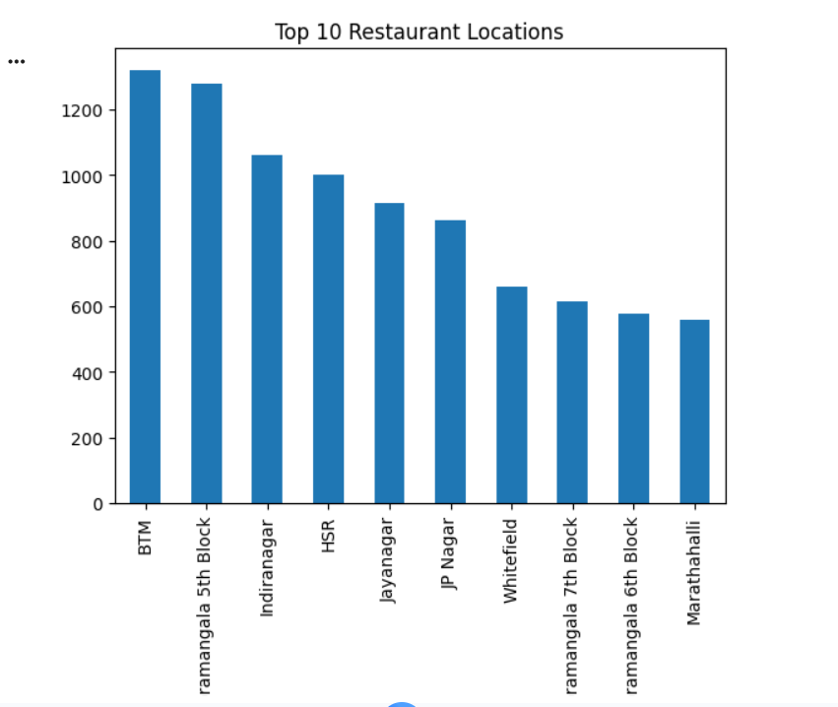

BTM, HSR, and Koramangala contain the highest number of restaurants, indicating these areas are major restaurant hubs.

Visualization 2: Restaurant Rating Distribution

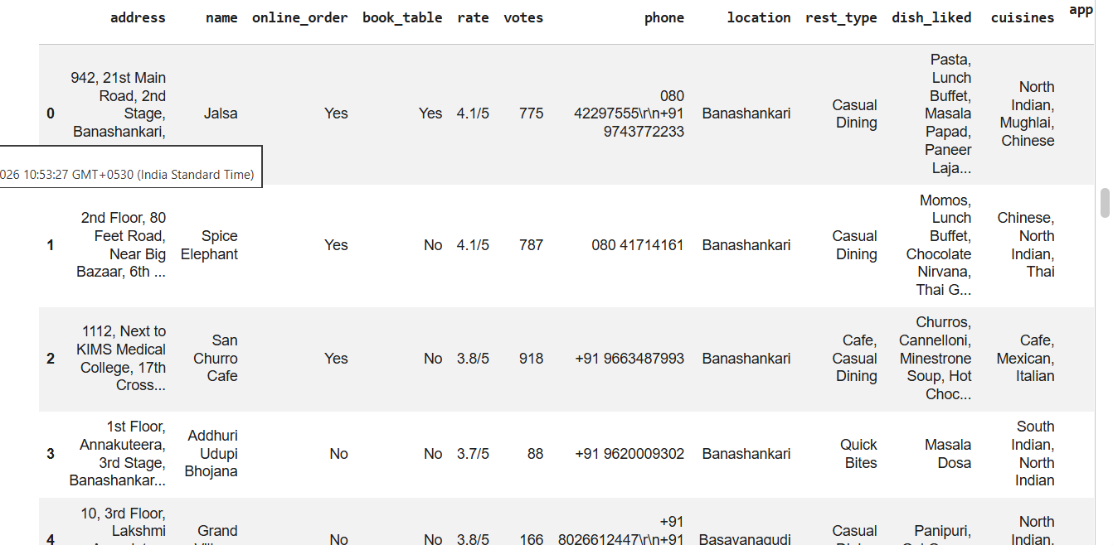

Observation:
Most restaurants have ratings between 3.5 and 4.2, indicating generally positive customer satisfaction.

Visualization 3: Top Cuisines
[Insert Graph Screenshot Here]
Observation:
North Indian, South Indian, Chinese, and Fast Food cuisines are among the most popular food categories.

Visualization 4: Online Order Availability
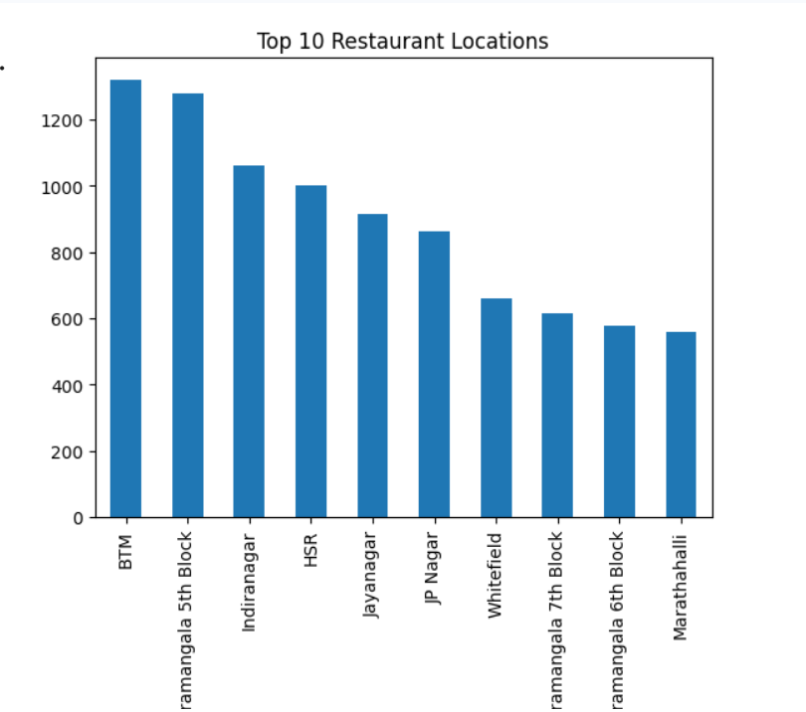
Observation:
A large percentage of restaurants support online ordering, reflecting strong demand for food delivery services.

Price vs Rating Analysis
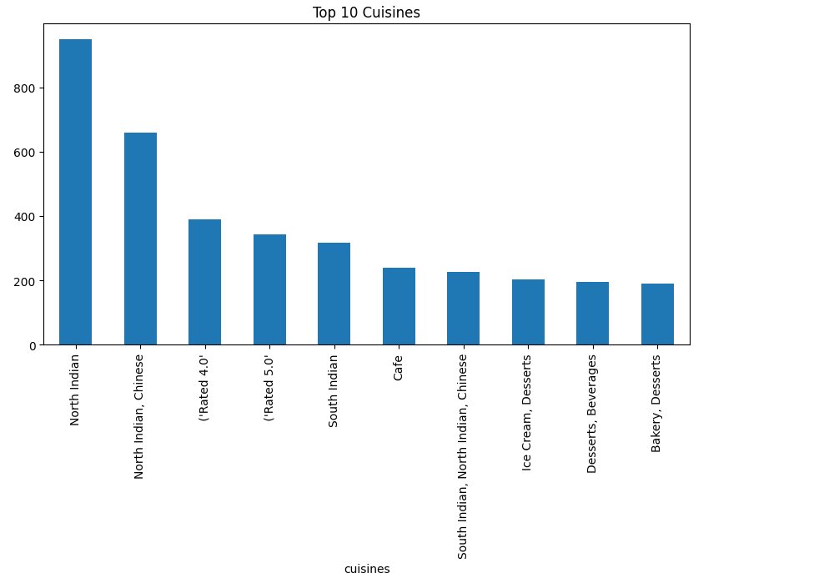
Observation:
Higher restaurant prices do not always guarantee higher customer ratings.

6. Key Findings
- BTM, HSR, and Koramangala are major restaurant hotspots.
- Most restaurants maintain ratings above 3.5.
- Online ordering services are widely available.
- Popular cuisines dominate customer demand.
- Pricing has only a moderate impact on restaurant ratings.

7. Recommendations
- Partner with highly rated restaurants to improve customer trust.
- Promote trending cuisines through featured listings.
- Use location-based recommendations for users.
- Highlight affordable restaurants with high ratings.
- Implement personalized restaurant suggestions based on customer preferences.

8. Conclusion
The Zomato dataset analysis provided valuable insights into restaurant performance, customer preferences, cuisine popularity, and location trends. The findings can help restaurant discovery platforms improve customer experience, optimize recommendations, and build stronger partnerships with restaurants.

